SLEEP DISORDER
The Diagnostic and Statistical Manual of Mental Disorders, Fifth Edition (DSM-5) classifies sleep–wake disorders into 10 categories:
- insomnia disorder,
- hypersomnolence disorder,
- narcolepsy,
- breathing-related sleep disorders,
- circadian rhythm sleep disorders,
- non-REM sleep arousal disorders,
- nightmare disorder,
- REM sleep behaviour disorder,
- restless legs syndrome, and
- substance- or medication-induced sleep disorder
SLEEP PHYSIOLOGY
- Humans typically have four to six cycles of non–rapid eye movement (NREM) and REM sleep each night, each cycle lasting 70 to 120 minutes. Usually there is progression through the four stages of NREM sleep before the first REM period.
- Stage 1 of NREM is the stage between wakefulness and sleep. Stages 3 and 4 sleep are called delta sleep (ie, slow-wave sleep).
- In REM sleep, there is a low-amplitude, mixed-frequency electroencephalogram, increased electric and metabolic activity, increased cerebral blood flow, muscle atonia, poikilothermia, vivid dreaming, and fluctuations in respiratory and cardiac rate.
- The elderly have lighter more fragmented sleep with more arousals and gradual reduction in slow-wave sleep.
- REM sleep is turned on by cholinergic cells. Dopamine has an alerting effect. Neurochemicals involved in wakefulness include norepinephrine and acetylcholine in the cortex and histamine and neuropeptides (eg, substance P and corticotropinreleasing factor) in the hypothalamus.
- Polysomnography (PSG) measures multiple electrophysiologic parameters simultaneously during sleep (eg, electroencephalogram, electrooculogram, and electromyogram) to characterize sleep and diagnose sleep disorders.

INSOMNIA
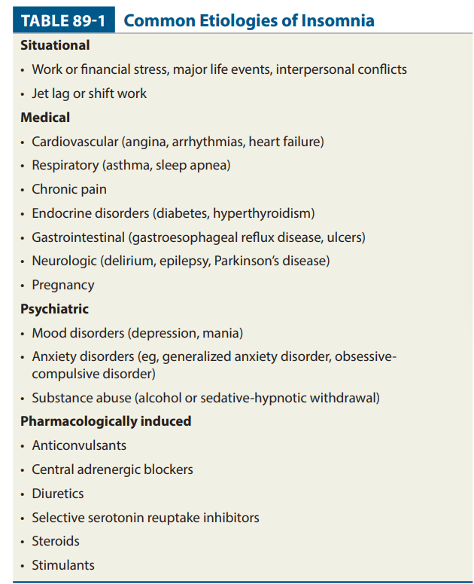
CLINICAL PRESENTATION AND DIAGNOSIS
- Patients with insomnia complain of difficulty falling asleep, maintaining sleep, or experiencing nonrestorative sleep.
- Transient (two or three nights) and short-term (1 month) may be related to medical or psychiatric disorders or medication, or it may be psychophysiologic.
- Causes of insomnia include stress; jet lag or shift work; pain or other medical problems; mood or anxiety disorders; substance withdrawal; stimulants, steroids, or other medications.
- In patients with chronic disturbances, a diagnostic evaluation includes physical and mental status examinations, routine laboratory tests, and medication and substance abuse histories.
TREATMENT
GOAL OF THERAPY
- Correct the underlying sleep complaint,
- Improve daytime functioning, and
- Avoid adverse drug effects.
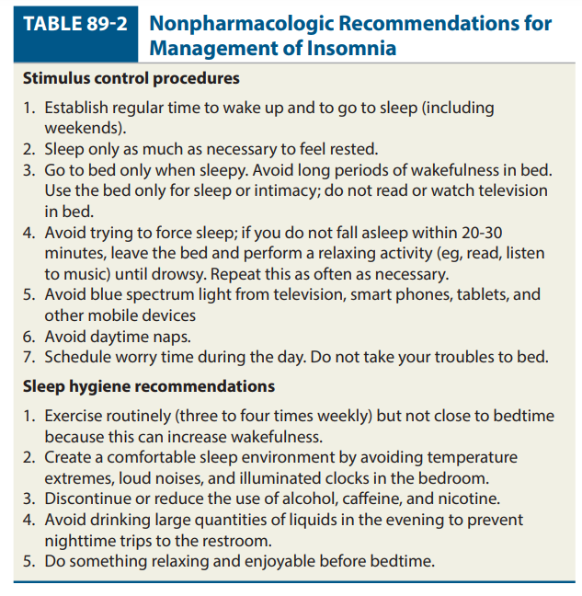
PHARMACOLOGICAL
BENZODIAZEPINES
DRUG | DOSE (mg)
Estazolam | 1-2
Temazepam | 15-30
Flurazepam | 15-30

- Antihistamines (eg, diphenhydramine, doxylamine, and pyrilamine) are less effective than benzodiazepines, but side effects are usually minimal. Their anticholinergic side effects may be problematic, especially in the elderly.
- Trazodone, 25 to 100 mg, is often used for insomnia induced by selective serotonin reuptake inhibitors or bupropion and in patients prone to substance abuse. Side effects include serotonin syndrome (when used with other serotonergic drugs), oversedation, α-adrenergic blockade, dizziness, and, rarely, priapism.
- Ramelteon is a melatonin receptor agonist selective for the MT1 and MT2 receptors. The dose is 8 mg at bedtime. It is well tolerated, but side effects include headache, dizziness, and somnolence. It is not a controlled substance. It is effective for patients with chronic obstructive pulmonary disease and sleep apnea.
- Valerian, a herbal product, is available without a prescription. The recommended dose is 300 to 600 mg. Purity and potency concerns are an issue. It may cause daytime sedation.

BENZODIAZEPINE ADVERSE EFFECTS
  - Side effects include drowsiness, psychomotor incoordination, decreased concentration, cognitive deficits, and anterograde amnesia which is minimized by using the lowest dose possible.
  - Tolerance to daytime CNS effects (eg, drowsiness, decreased concentration) may develop in some individuals.
  - Tolerance to hypnotic effects develops after 2 weeks of continuous use of triazolam. Efficacy of flurazepam, quazepam, and temazepam lasts for at least 1 month of nightly use. Estazolam reportedly maintains efficacy at maximum dosage for up to 12 weeks.
  - Rebound insomnia occurs frequently with high doses of triazolam, even when used intermittently.
  - Rebound insomnia is minimized by using the lowest effective dose and tapering the dose upon discontinuation
NONBENZODIAZEPINE GABAA AGONISTS
- Zolpidem has minimal anxiolytic and no muscle relaxant or anticonvulsant effects. . The usual dose is 5 mg in women, the elderly, and those with liver impairment, and 5 to 10 mg in men. Common side effects are drowsiness, amnesia, dizziness, headache, and gastrointestinal (GI) complaints.
- Zaleplon has a rapid onset, a half-life of ~1 hour, and no active metabolites. It also binds to the GABAa receptor. The most common side effects are dizziness, headache, and somnolence. The recommended dose is 10 mg (5 mg in the elderly).
- Eszopiclone has a rapid onset and duration of action of up to 6 hours. The most common adverse effects are somnolence, unpleasant taste, headache, and dry mouth. It may be taken nightly for up to 6 months
SLEEP APNEA
Apnea is repetitive episodes of cessation of breathing during sleep.
TWO TYPES-
- OBSTRUCTIVE SLEEP APNEA
  - Obstructive sleep apnea (OSA) is potentially life threatening and characterized by repeated episodes of nocturnal breathing cessation. It is caused by occlusion of the upper airway, and blood oxygen (O2 ) desaturation can occur.
  - Episodes may be caused by obesity or fixed upper airway lesions, enlarged tonsils, amyloidosis, and hypothyroidism.
  - Complications include arrhythmias, hypertension, cor pulmonale, and sudden death.
  - Heavy snoring, severe gas exchange disturbances, respiratory failure, and gasping occur in severe episodes. Patients with OSA usually complain of excessive daytime sleepiness. Other symptoms are morning headache, poor memory, and irritability.
  - The apneic episode is terminated by a reflex action in response to the fall in blood O2 saturation that causes an arousal with resumed breathing.

TREATMENT
Goal of Treatment: The goal is alleviate sleep-disordered breathing (Fig. 70–1).
NON PHARMACOLOGICAL THERAPY
Treatments of choice (eg, weight loss [for all overweight patients], tonsillectomy, nasal septal repair, and nasal positive airway pressure [PAP], which may be continuous or bilevel). Other surgical therapies, such as uvulopalatopharyngoplasty and tracheostomy, may be necessary in severe cases.
PHARMACOTHERAPY
Avoid of all CNS depressants and drugs that promote weight gain. Angiotensin-converting enzyme (ACE) inhibitors can also worsen sleep-disordered breathing. Modafinil and armodafinil are approved by the FDA to improve wakefulness in those with residual daytime sleepiness. They should be used only in patients without cardiovascular disease who are using optimal PAP therapy.
- CENTRAL SLEEP APNEA
- Central sleep apnea (CSA), less frequent than OSA, is characterized by repeated episodes of apnea caused by temporary loss of respiratory effort during sleep. It may be caused by autonomic nervous system lesions, neurologic diseases, high altitudes, opioid use, and congestive heart failure.
TREATMENT
PAP with or without supplemental O2 improves CSA.
Acetazolamide causes metabolic acidosis that stimulates respiratory drive and may be beneficial for high altitude, heart failure, and idiopathic CSA
NARCOLEPSY
- Essential features are sleep attacks, cataplexy, hypnagogic and hypnopompic hallucinations, and sleep paralysis. Patients complain of excessive daytime sleepiness, sleep attacks that last up to 30 minutes, fatigue, impaired performance, and disturbed nighttime sleep.
- Cataplexy, which occurs in 70% to 80% of narcoleptics, is sudden bilateral loss of muscle tone with collapse. It is often precipitated by highly emotional situations.
- The hypocretin/orexin neurotransmitter system may play a central role in narcolepsy. An autoimmune process may cause destruction of hypocretin-producing cells.
TREATMENT
GOAL OF THERAPY
The goal is to maximize alertness during waking hours and improve quality of life.
PHARMACOTHERAPY
DRUG | INITIAL DOSE (mg) | USUAL DOSE (mg)
Dextroamphetamine | 5-10 | 5-60
Dextroamphetamine/ amphetamine salts | 5-20 | 5-60
Modafinil | 100-200 | 200-400

AGENTS FOR CATALEPSY
DRUG | INITIAL DOSE (mg) | USUAL DOSE (mg)
Fluoxetine | 10-20 | 20-80
Nortriptyline | 50-100 | 50-200
Selegiline | 5-10 | 20–40

- What is insomnia? Name any two drug used in insomnia (2)
- Discusss the etiology and management of sleep disorders (7.5)

